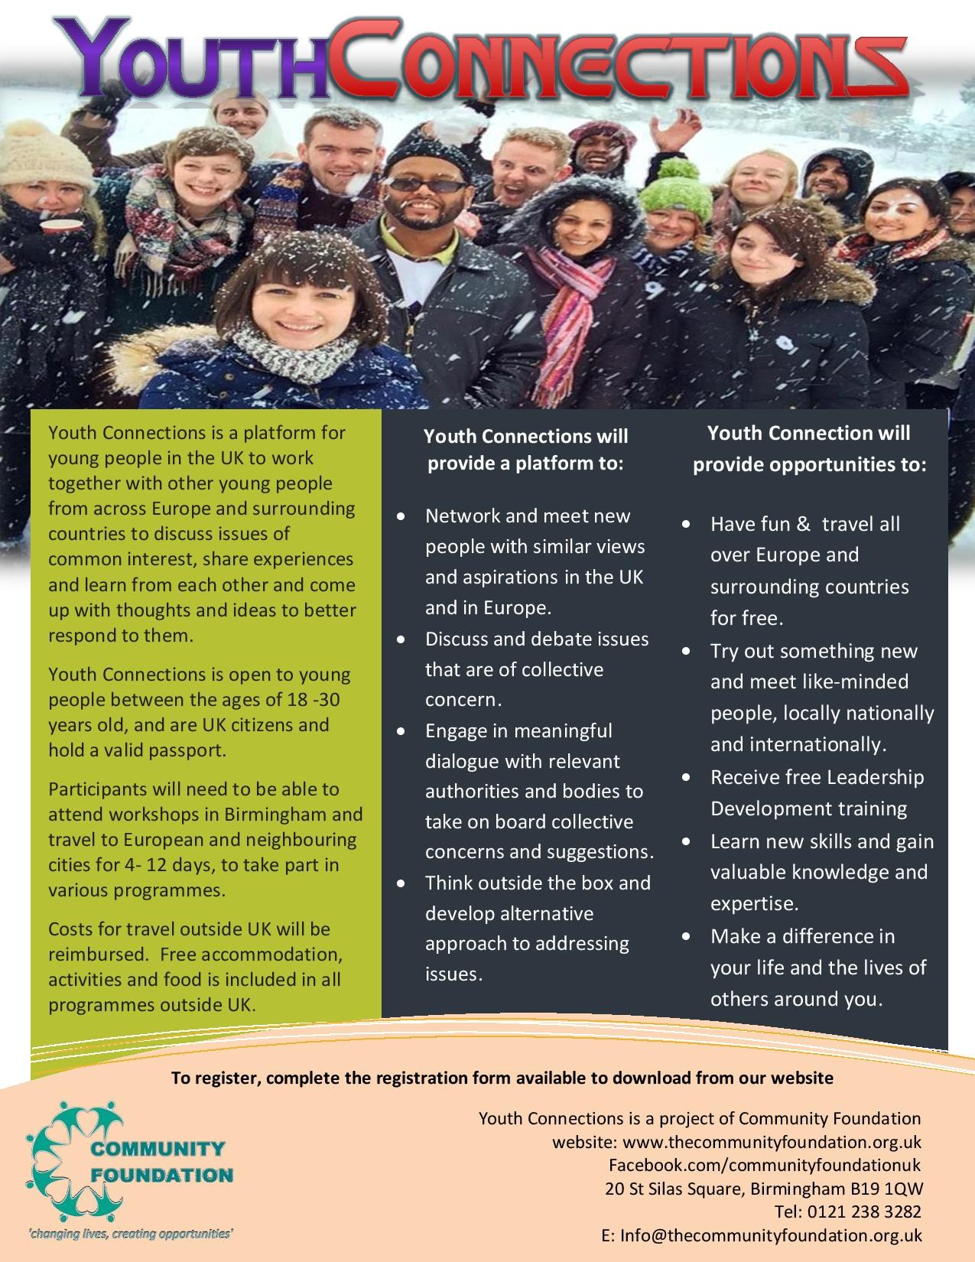

|  |  |  |
| --- | --- | --- |
| **YOUTH CONNECTIONS APPLICATION FORM** | | |
| Full Passport Name |  | |
| Age |  | |
| Gender |  | |
| Ethnicity |  | |
| Home Address |  | |
| Email |  | |
| Home / Emergency  Tel Number |  | |
| Mobile Number |  | |
| Highest Qualification  & date obtained |  | |
| Occupation & Org Address |  | |
| Dietary Requirements: |  | |
| Medical conditions |  | |
| Please tell us about yourself and your current/pastpaid or voluntary education/youth/community roles or activities you are involved with and what you can offer/bring to the group? | | |
|  | | |
| **Can you confirm you have a UK Passport with minimum 6 months validity after date of travel and are free to travel outside the EU?**  **Yes / No** | | |
| **Passport Expiry date** | |  |

|  |
| --- |
| Please give us details of any education/youth/community organisations you have been involved with  Org name…………………………………………………………………………………………………..  Contact person…………………………………………………………………………………………...  Email…….…………………………………………………………………………………………………..  Tel……………………………………………….……………………………………………….……….…. |
| **I would like to become a member of Youth Connections and agree to:**  Receive regular communication on Youth Connections events & activities  Yes  No  Take part in Youth Connections event planning meetings  Yes  No  Take part in Youth Connections UK based workshops and seminars  Yes  No  Take part in Youth Connections International workshops and residential  Yes  No  Take part in the next Youth Connections International youth exchange programme  Yes  No  Enter Youth exchange programme name here: _______________________________________________  Country Location: ______________________________________________________________________  Exchange Dates: _______________________________________________________________________  Signed:……………………………………………………………..  Date….………………………………………………………………  **We reserves the right to cancel the participation of any individual selected to take part in this programme, if they do not follow the code of conduct and or participate in the activities.** |
| **Please attach scan/copy of the photo page of your passport with this application form.**  You can use your mobile camera to take a photo of your passport page (make sure to take  photo without your flash) |

**Please complete and return this application form to:**

Email: info@thecommunityfoundation.org.uk

Post: Community Foundation, 20 St Silas Square, Birmingham, B19 1WQ

For further information about Community Foundation, please visit:

www.thecommunityfoundation.org.uk Facebook: communityfoundationuk

Tel:0121 238 3282